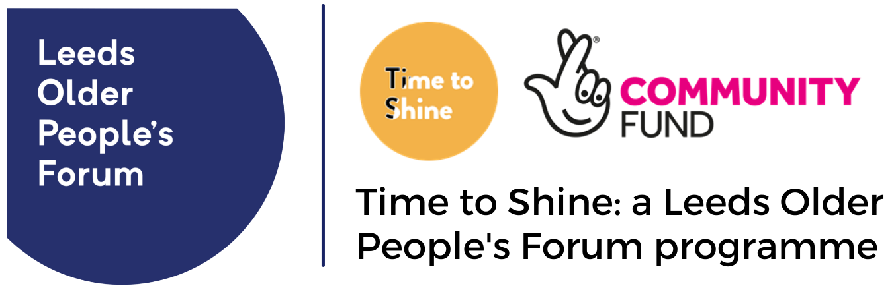
21 test and learn questions that the Time to Shine programme aims to answer

Key word: | Question # | Test and Learn questions to answer: | Outcomes link:
Barriers: | 1 | What barriers to participation are happening now for participants and volunteers? | 2
Prevention: | 2 | Does Time to Shine help prevent social isolation and/or loneliness? | 1
Sustainability: | 3 | What enables successful projects / programmes to become sustainable? | 4
Reaching out: | 4 | Are we reaching socially isolated and/or lonely older people? How? | 1
Diversity: | 5 | What approaches work best to engage target groups of people most at risk of social isolation and/or loneliness? | 2
Replicable: | 6 | Can elements of the programme be replicated or expanded successfully? | 4
Commissioning: | 7 | How has the learning from Time to Shine been used to inform commissioning in Leeds? | 4
Legacy: | 8 | What is Time to Shine's legacy? Can impact be measured beyond 2021? | 1
Feelings: | 9 | How does loneliness and/or social isolation make people feel? | 1
Complexities: | 10 | What are the complexities behind loneliness and people's experiences of loneliness? | 3
Triggers: | 11 | What attracted or motivated people to join in an activity? | 2
Co-production: | 12 | To what degree has the programme been led by a diverse group of older people? | 3
Impact 1: | 13 | How has involvement in Time to Shine made individual people feel? | 1
Impact 2: | 14 | Have people developed social networks / accessed other services after becoming involved? | 2
Approaches: | 15 | How has the learning from Time to Shine been used to inform delivery partner or Time to Shine approaches? | 3
(Not) worked: | 16 | What has worked? What hasn't worked? Why? For whom? | 3
Awareness: | 17 | Have we increased awareness of social isolation and/or loneliness and the support services available in Leeds? | 2
Stigma: | 18 | Have we reduced the stigma of social isolation and/or loneliness and changed public perceptions? How? | 4
Partnerships: | 19 | Have new partnerships been formed? Are organisations working 'better together'? | 4
Benefits: | 20 | How have older people and communities benefited from new partnerships and new ways of working? | 4
Intergenerational: | 21 | What has been the impact of intergenerational approaches on both older people and their wider communities? | 2

