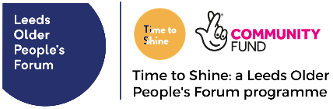
Test and Learn case study
Project name:
Form completed by: Date:
Which Time to Shine indicator does this form link to?
- Lessons for professional practice, planning and/or service development (indicator C)
- Community engagement and participation in activities (indicator F)
- Informal partnerships and outcomes (indicator M)
- None of the above

Please outline the issue, situation or question you’ll explore in this Test and Learn example
What did you plan to do?
What expectations did you have?
How did reality differ from your expectations? What was good? What was not so good?
Why do you think this happened? What information did you gather from others to support this?
What will you do differently next time?
Please list the key learning points (in about 100 words)
Are there any people / organisations in particular who would benefit from this learning?
Do you have anything else to add?

Thank you for being part of Time to Shine and sharing your learning and experiences. Please complete the consent form to let us know if we can share this information publicly.

