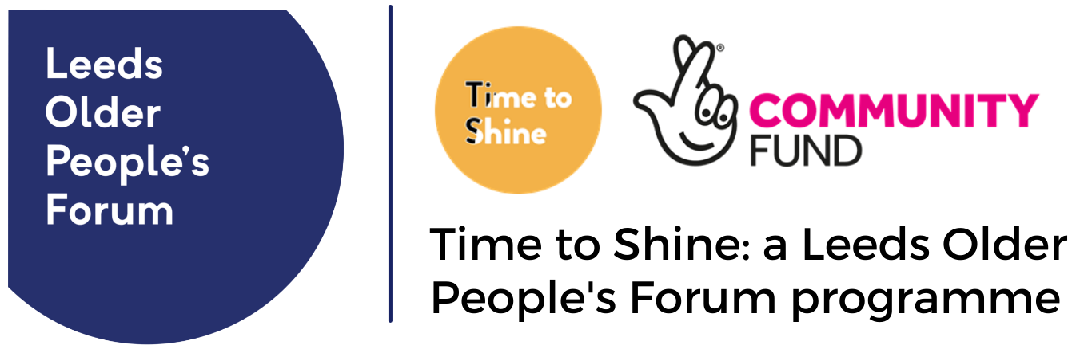
Case study to share an individual’s story, outcomes and experiences
Project name:
This is the story of:
May we include this name if we share this story with others? Yes / No / Do not share this story
Form completed by: Date:
Contact details of the person filling in this form:

What was life like for you before becoming involved in the project? How did you feel?
Why did you get involved?
Who or what helped you? How did this help?
What has changed for you as a result of this project?
What is life like for you now? How do you feel?
What would you like to do next?
What would you say to others who are thinking of getting involved?
Do you have anything else to add?

Thank you for being part of Time to Shine and sharing your personal experience. Please complete the consent form to let us know if we can share this information publicly.

