Time to Shine (TTS) monitoring and evaluation (M&E) report to the Core Partnership
Quarters x & x (Dates from and to xx), Author xx, Date xx
Key to colours:
 | TTS indicators |  | r | Red rating |  | a | Amber rating |  | g | Green rating

Positives:

Issues or concerns:

Time to Shine – outcome 1
Each year beneficiaries report that they are less isolated as a result of a programme intervention.

 | Time to Shine indicators relating to outcome 1 (target) | Qx | Qx | All Qs
A | Individual people involved in programme each year (15,000)
 | Older people who regularly participate or volunteer (10,000)
B | Percentage of beneficiaries with the same or improved scores on social isolation or loneliness using data from Common Measurement Framework (CMF) questionnaires or its equivalent (85%)
C | Case studies received from delivery partners
Narrative relating to outcome 1 and the outcome 1 Red Amber Green (RAG) ratings

Time to Shine – outcome 2
Programme beneficiaries feel confident and able to participate in their communities by 2021.

 | Time to Shine indicators relating to outcome 2 (target) | Qx | Qx | All Qs
D | Percentage of beneficiaries with the same or improved scores on social contact, social participation or wellbeing using data from Common Measurement Framework (CMF) questionnaires or its equivalent (50%)
 | Number of target beneficiaries by 2021 - MEN (2,000)
 | Number of target beneficiaries– BME Elders (600)
 | Number of target beneficiaries– LGBT Seniors (250)
 | Number of target beneficiaries– Learning Disabled (100)
E | Number of activity sessions delivered (*since 2018)
 | Projects/activities specifically relating to target groups
F | Case studies on community engagement and participation
G | Qualitative research (by older researchers, delivery partners and academics) as part of the local evaluation of Time to Shine.
Narrative relating to outcome 2 and the outcome 2 RAG ratings

Time to Shine – outcome 3
Older people have been actively involved in managing, designing, delivering and evaluating the programme.

 | Time to Shine indicator relating to outcome 3 (target) | Qx | Qx | All Qs
H | Number of older people trained and actively working as researchers to support the local evaluation. (50)
I | Number of older people involved through Leeds Older People’s Forum or Time to Shine to design, develop, deliver, steer or manage the programme. (150)
J | Number of older people involved through delivery partners to design, develop, deliver, steer or manage their Time to Shine project (800)
Narrative relating to outcome 3 and the outcome 3 RAG ratings

Time to Shine – outcome 4
Our wider partnership will expand each year and will work better together to coordinate services and support for isolated older people.

 | Time to Shine indicators relating to outcome 4 (target) | Qx | Qx | All Qs
K | Number in wider partnership from baseline of 45 (76)
 | Qualitative research focussing on new and existing partnerships through local evaluation.
L | In depth case studies on systems change relating to the programme or projects, with a focus on the quality of partnerships, coordination of services and referral pathways
M | Case studies from delivery partners with a focus on informal partnerships, systems change and outcomes
Narrative relating to outcome 4 and the outcome 4 RAG ratings

Local evaluation update:

National evaluation update:

Additional funding secured:

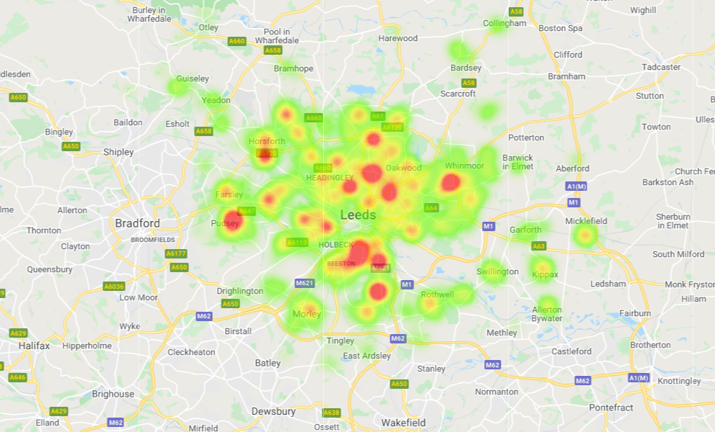
Postcode data for xx beneficiaries showing the geographical spread of home addresses for people involved in Time to Shine.

Legacy: Delivery partner reflections on any long-term changes TTS has brought to their organisation's processes and practice

Learning: Delivery partner reflections on their learning from their involvement in Time to Shine

Case study:

Quotes:

Photographs:

Items for discussion by the Core Partnership:

