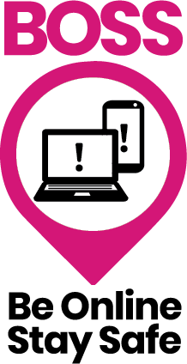

Name
Start date
End Date

Welcome to the "Be Online, Stay Safe" course. Over the next few weeks, you will learn how to use the internet effectively and stay safe while doing so.

Please complete the following questions:

How confident do you feel in your ability to identify online scams and fake news online
Please circle the answers:

1 - Not confident at all
2 - Fairly confident
3. Confident

Why are you interested in improving your digital media literacy skills ? (Select all that apply)

a) Stay connected with family and friends
b) To search the internet and find information
c) To send emails to businesses to save time on the phone
d) To feel more confident going online
e) Learn more about scams and how to prevent them
f) I want to be able to do things online independently without asking friends or family
g) Other (please state)

Do you have any concerns before starting the course?

Do you have any health conditions we need to be aware of? (e.g dyslexia, vision or hearing impairment.)

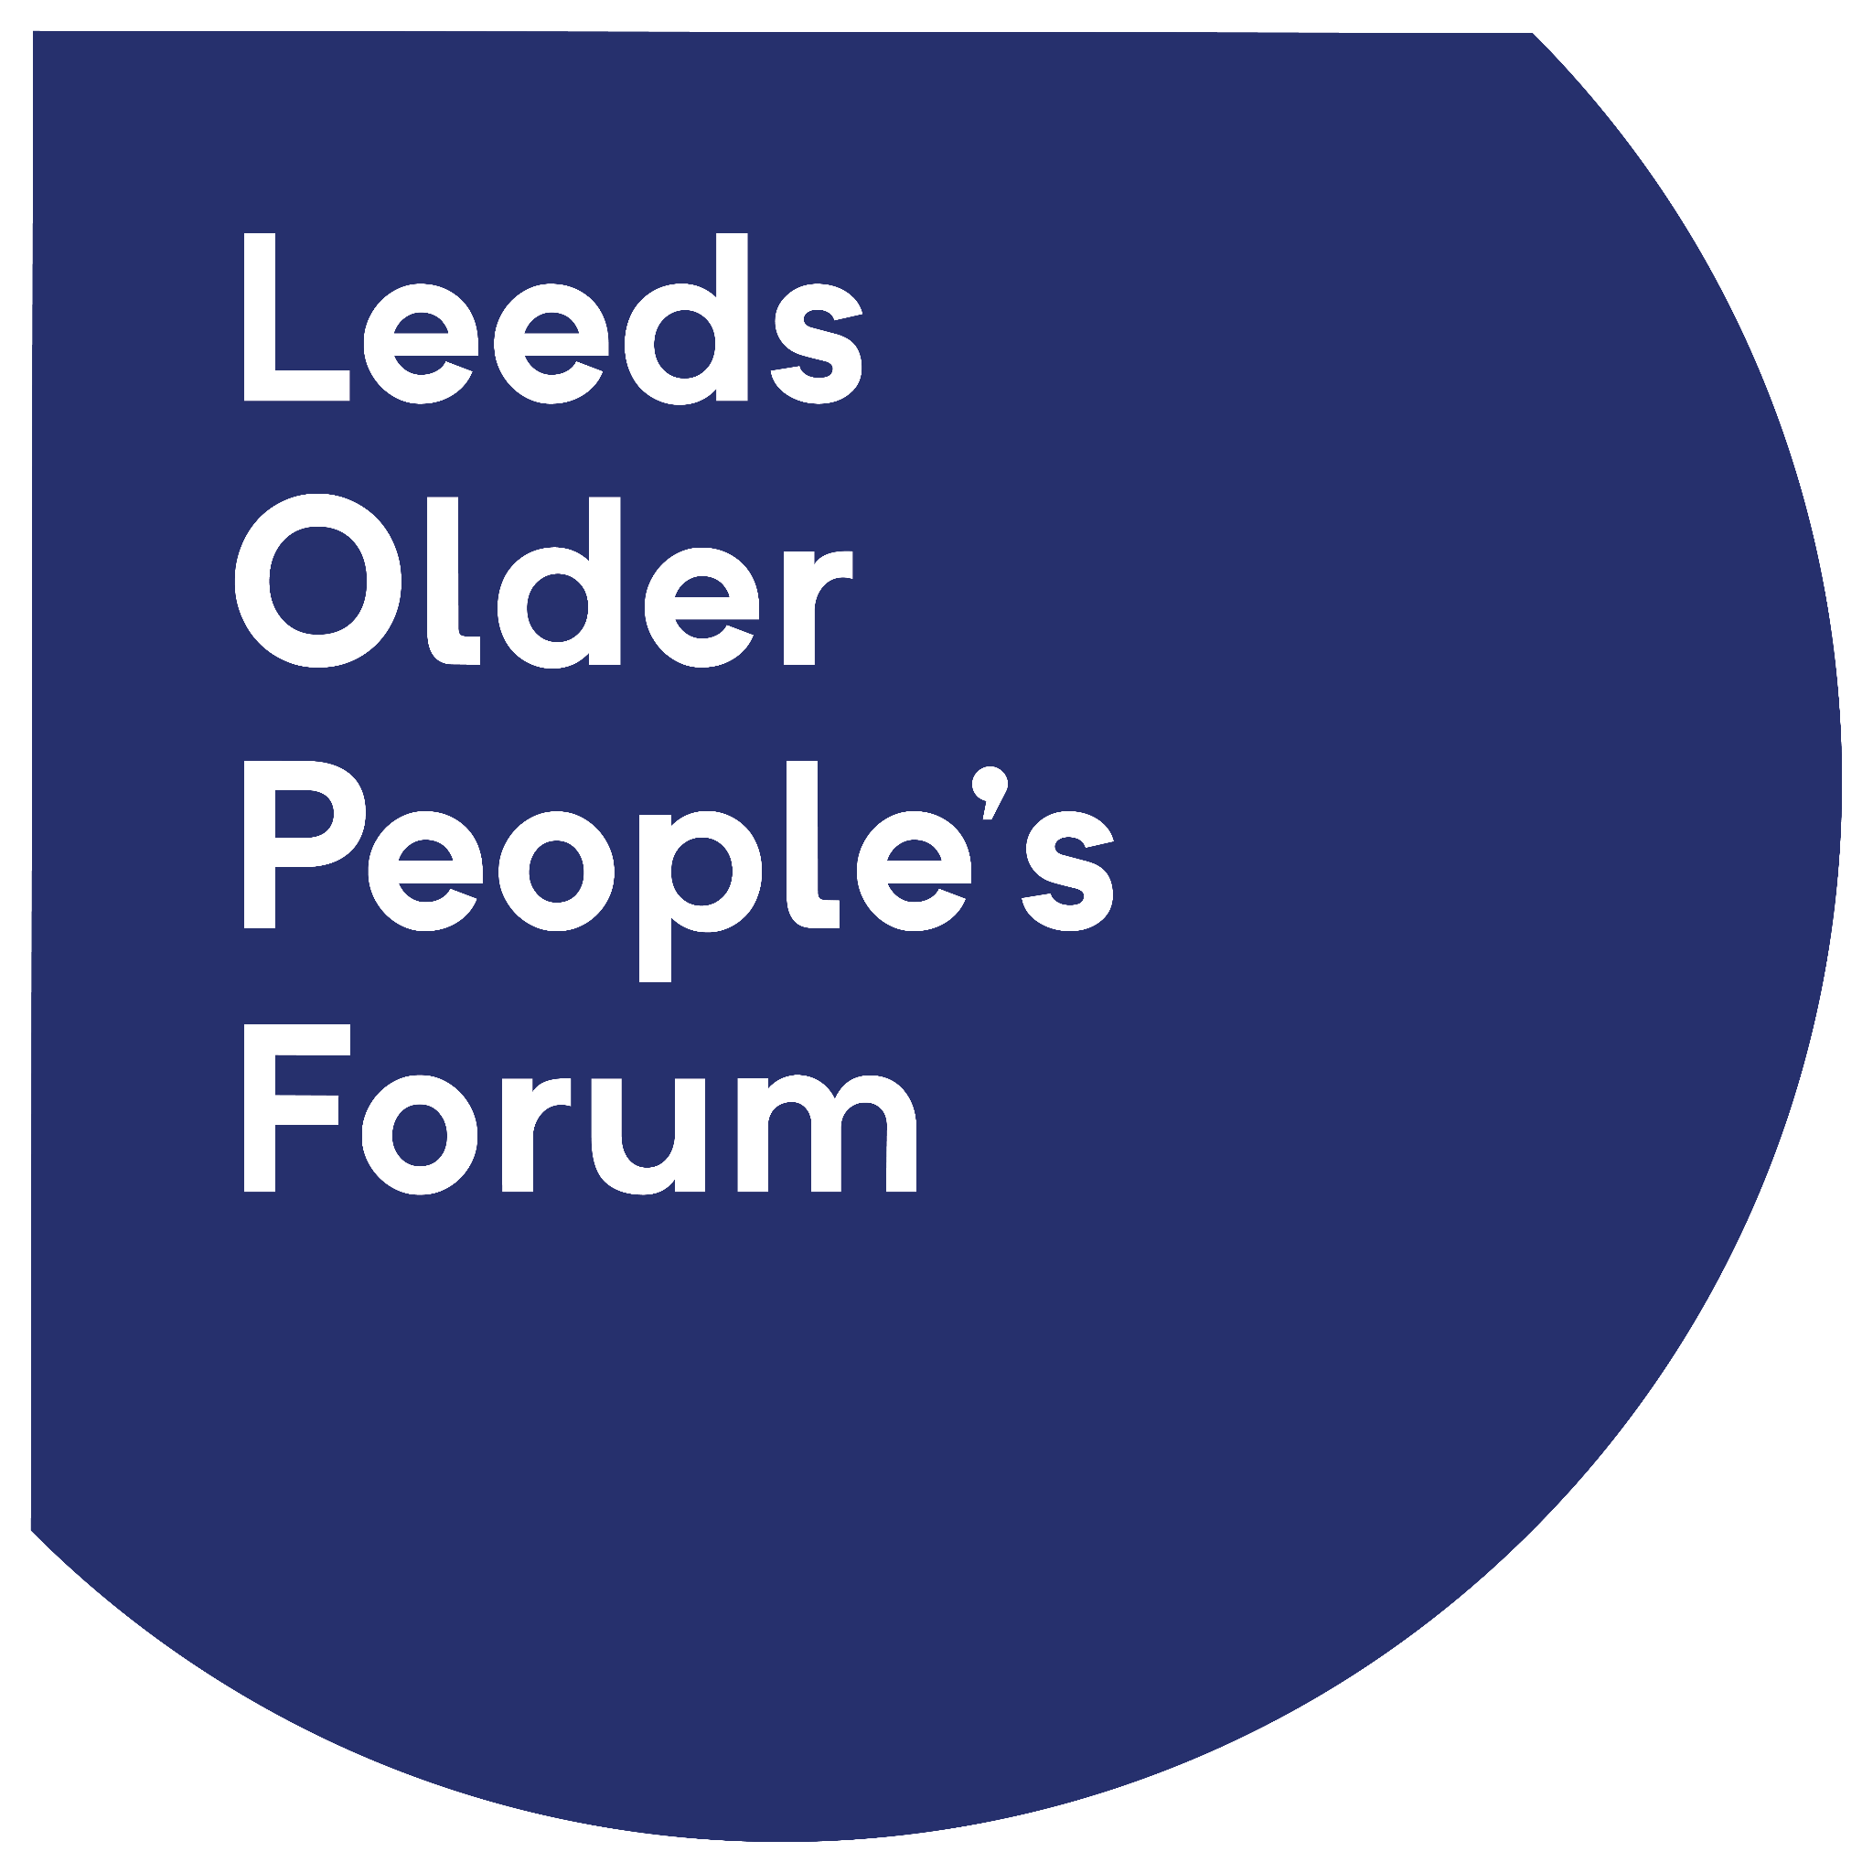

Below is a list of skills which you will learn whilst on the course please complete the table below using the following as a guideline

Confident - You feel confident and capable of completing the skill independently.

Fairly confident - You have some knowledge or understanding of the skill.

Not confident - You have not yet acquired the knowledge or skills required for this task and need instruction and support to learn how to do it.

 | Start of course assessment
Skills | Confident | Fairly confident | Not confident
Connect your phone to WIFI
Arrange your apps on home screen
Understand phone settings and how to use them
Send an email
Delete an email
Unsubscribe from emails and block scam emails
Recognise a scam email
Attach a photo to an email
Find information on the internet
Identify fake news and scams online
Recognise online scams
Know how to protect yourself from online scams
Find trusted health information online
Contact your Doctor online
Use Google Translate (optional)

Final assessment
Name:

 | End of course assessment
Skills | Confident | Fairly confident | Not confident
Connect your phone to WIFI
Arrange your apps on home screen
Understand phone settings and how to use them
Send an email
Delete an email
Unsubscribe from emails and block scam emails
Recognise a scam email
Attach a photo to an email
Find information on the internet
Identify fake news and scams online
Recognise online scams
Know how to protect yourself from online scams
Find trusted health information online
Contact your Doctor online
Use Google Translate (optional)

1 What are the most important things you learned during the course?

2 What changes have you made to stay safe online

General feedback - Please let us know what you enjoyed/didn’t enjoy about the course and what changes and suggestions you have to improve the course (Please continue over page)

